CRT FEB

Title of the Program : Web Application Designing.
Target Audience : II Year Students from CSE
Venue : Main Seminar Hall, Anantha Lakshmi Institute of Technology and Sciences
Date : 03/02/2025 to 08/02/2025
Time : 9.00 FN to 4.00 AN
Mode : Offline
Trainer Name : Ms. Navya Sri.
No of Students : 255
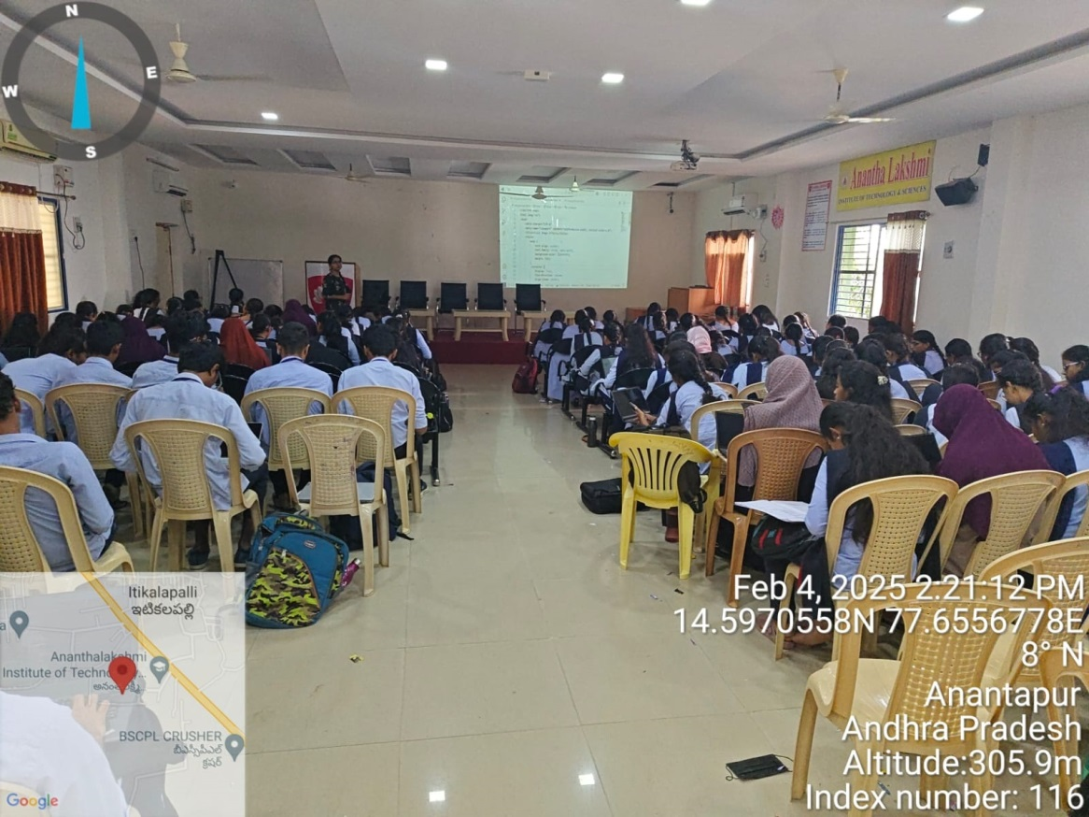

Title of the Program : Web Application Designing.
Target Audience : II Year Students from ECE, CE & ME
Venue : Seminar Hall, Anantha Lakshmi Institute of Technology and Sciences
Date : 03/02/2025 to 10/02/2025
Time : 9.00 FN to 4.00 AN
Mode : Offline
Trainer Name : Mr. P.G.V.Koushik
No of Students : 280

